**Mogappair, Chennai 600 050**

Done By

LAKSHA PRASHANTH

XII – B

**1. Acknowledgements**

**2. Concepts Used**

**3. Introduction**

**4. Header Files Used**

**5. Program Code**

**6. Output**

**7. System Requirements**

**8. Bibliography**

**Acknowledgement**

**I would like to express my regards and gratitude**

**To my computer science teacher Ms.Uma Arthi for her**

**Encouragement and invaluable insight that has led to**

**the completion of this project.**

**I would like to thank Ms.Girija our lab attendant for**

**Providing the necessary apparatus during the course of**

**this project.**

* Classes and Structures
* Binary Files
* Functions
* Graphics

In this game you have to move the paddle

And deflect the ball.

The ball finally hits the bricks which break.

Some bricks only break after a few hits.

Earn points by destroying the bricks and completing each level.

* Graphics.h
* Iostream.h
* Stdio.h
* Conio.h
* Dos.h
* Stdlib.h
* Process.h
* Fstream.h
* String.h

#include<graphics.h>

#include<iostream.h>

#include<conio.h>

#include<dos.h>

#include<stdlib.h>

#include<process.h>

#include<stdio.h>

#include<fstream.h>

#include<string.h>

struct player

{

char name[20];

int score;

};

void paddle(int &x)

{

setfillstyle(1,RED);

bar(x,450,x+40,460);

}

class ball

{

float x,y;

public:

int xt,yt;

ball()

{

x=250;

y=430;

int r=random(2);

if(r==0)

xt=-1;

else

xt=1;

yt=-1;

}

float rety()

{return y;}

float retx()

{return x;}

void chgx(int X,int Y)

{x=X;y=Y;}

void disp()

{

circle(x,y,7);

setfillstyle(1,RED);

floodfill(x+1,y+1,BLUE);

}

void move()

{

x+=xt*1.2;

y+=yt*1.2;

}

void left()

{

if(x<10 || x>600)

xt=-xt;

}

int down(int X);

};

int ball::down(int X)

{

if(y<10)

yt=-yt;

else if((y>=445&&y<=460) && (x>=X && x<=X+40))

yt=-1;

else if(y>445)

return 0;

return 1;

}

class level1

{

int a[15];

public:

level1();

int size()

{return 15;}

void rect()

{

setfillstyle(8,RED);

if(a[0]==1)

{

bar(90,50,130,70);

rectangle(90,50,130,70);

}

if(a[1]==1)

{

bar(130,50,170,70);

rectangle(130,50,170,70);

}

if(a[2]==1)

{

bar(170,50,210,70);

rectangle(170,50,210,70);

}

if(a[3]==1)

{

bar(210,50,250,70);

rectangle(210,50,250,70);

}

if(a[4]==1)

{

bar(250,50,290,70);

rectangle(250,50,290,70);

}

if(a[5]==1)

{

bar(290,50,330,70);

rectangle(290,50,330,70);

}

if(a[6]==1)

{

bar(330,50,370,70);

rectangle(330,50,370,70);

}

if(a[7]==1)

{

bar(370,50,410,70);

rectangle(370,50,410,70);

}

if(a[8]==1)

{

bar(410,50,450,70);

rectangle(410,50,450,70);

}

if(a[9]==1)

{

bar(450,50,490,70);

rectangle(450,50,490,70);

}

if(a[10]==1)

{

bar(180,70,220,90);

rectangle(180,70,220,90);

}

if(a[11]==1)

{

bar(220,70,260,90);

rectangle(220,70,260,90);

}

if(a[12]==1)

{

bar(260,70,300,90);

rectangle(260,70,300,90);

}

if(a[13]==1)

{

bar(300,70,340,90);

rectangle(300,70,340,90);

}

if(a[14]==1)

{

bar(340,70,380,90);

rectangle(340,70,380,90);

}

}

int score();

void check(int ,int ,int& , int&);

int reta(int i)

{return a[i];}

};

void level1::level1()

{

for(int i=0;i<15;i++)

a[i]=1;

}

void level1::check(int x,int y,int &xt,int &yt)

{

int m=90,n=50;

for(int i=0;i<15;i++,m+=40)

{

if(i==10)

{

m=180;

n=70;

}

if(a[i])

{

if((x>=m && x<=m+40) && (y==50 || y==70 || y==90))

{

sound(500);

delay(70);

nosound();

yt=-yt;

a[i]=0;

}

if(y>=n && y<=n+20)

if(x==m || x==m+40)

{

sound(300);

delay(50);

nosound();

xt=-xt;

a[i]=0;

break;

}

}

}

}

class level2

{

int b[20][2];

public:

level2();

void rect();

void check(int ,int ,int &,int&);

int reta(int i)

{return b[i][0];}

int retb(int i)

{return b[i][1];}

};

level2::level2()

{

for(int i=0;i<20;i++)

{

b[i][0]=1;

if(i%2)

b[i][1]=1;

else

b[i][1]=0;

}

}

void level2::rect()

{

int m=90,n=50;

for(int i=0;i<20;i++,n+=30)

{

if(i==10)

{

m=430;

n=50;

}

if(b[i][0]==1)

{

if(b[i][1]==1)

setfillstyle(1,BLUE);

else

setfillstyle(8,RED);

bar(m,n,m+40,n+20);

rectangle(m,n,m+40,n+20);

}

}

setfillstyle(1,RED);

}

void level2::check(int x,int y,int &xt,int &yt)

{

int m=90,n=50;

for(int i=0;i<20;i++,n+=30)

{

if(i==10)

{

m=430;

n=50;

}

if(b[i][0])

{

if(x>=m && x<=m+40)

if(y>=n && y<n+20)

{ yt=-yt;

sound(500);

delay(70);

nosound();

if(b[i][1]==1)

b[i][1]=0;

else

b[i][0]=0;

}

if(y>=n && y<=n+20)

if(x==m || x==m+40)

{

sound(200);

delay(70);

nosound();

xt=-xt;

if(b[i][1]==1)

b[i][1]=0;

else

b[i][0]=0;

break;

}

}

}

}

void help()

{

cleardevice();

setcolor(11);

setbkcolor(BLACK);

settextstyle(5,0,7);

outtextxy(170,20,"HELP");

settextstyle(3,0,2);

setcolor(9);

outtextxy(90,190,"1.Destroy all the bricks using the ball");

outtextxy(90,220,"2.Use your paddle to deflect the ball");

outtextxy(90,250,"3.If the ball goes below the paddle, then its...");

outtextxy(140,280,"...GAME OVER for you");

getch();

}

int play(int level,ball b,int x)

{

int a,c,score=0,i;

level1 l1;

level2 l2;

setbkcolor(WHITE);

setcolor(BLUE);

setfillstyle(1,RED);

do

{

cleardevice();

if(level==1)

{

l1.rect();

l1.check(b.retx(),b.rety(),b.xt,b.yt);

}

else if(level==2)

{

l2.rect();

l2.check(b.retx(),b.rety(),b.xt,b.yt);

}

paddle(x);

b.disp();

a=b.down(x);

b.left();

b.move();

if(kbhit())

{

c=getch();

if(c==0)

c=getch();

if(c==77)

x+=20;

else if(c==75)

x-=20;

else if(c=='q')

exit(1);

}

if(level==1)

delay(0.4);

else

delay(1.5);

}while(a!=0);

cleardevice();

if(level==1)

for(i=0;i<15;i++)

score+=!l1.reta(i);

else if(level==2)

for(i=0;i<20;i++)

score+=!l2.reta(i);

return score;

}

void read(char *A,player p)

{

player S[20];

ofstream fout(A,ios::binary|ios::app);

fout.write((char*)&p,sizeof(p));

fout.close();

}

void disp(char *A)

{

int i=0;

ifstream fin(A,ios::binary);

player s[30];

cout<<"\n\tNAME\t\tSCORE\n";

while(fin.read((char*)&s[i],sizeof(s[i++])))

cout<<"\n\t"<<s[i].name<<"\t\t"<<s[i].score;

fin.close();

}

void del(char *A)

{

player S[20],t;

int i=0,j,k;

ifstream fin(A,ios::binary);

ofstream fout("New",ios::binary|ios::noreplace);

while(fin.read((char*)&S[i],sizeof(S[i])))

{

i++;

}

clrscr();

for(j=0;j<i-1;j++)

for(k=0;k<i-1-j;k++)

if(S[k].score<S[k+1].score)

{

t=S[k];

S[k]=S[k+1];

S[k+1]=t;

}

for(j=0;j<5 && j<i;j++)

fout.write((char*)&S[j],sizeof(player));

fout.close();

fin.close();

remove(A);

rename("NEW",A);

cout<<"\nDeleting......";

getch();

}

void modify(char *A,player p)

{

fstream f(A,ios::binary|ios::out|ios::in);

player S;

long int a;

cout<<"\n\t\tMODIFYING!!!!!! "<<A;

cout<<p.name<<" "<<p.score;

getch();

while(f.read((char*)&S,sizeof(S)))

if(strcmpi(S.name,p.name)==0)

{

strcpy(S.name,p.name);

S.score=p.score;

cout<<"\nModifying:::::::::\a\a\a\a"<<sizeof(S);

delay(5000);

a=f.tellp();

a-=sizeof(S);

f.seekg(a,ios::beg);

f.write((char *)&p,sizeof(p));

}

f.close();

}

void main()

{

int gd=DETECT,gm,x=250,c,ch,i,k,y,score,a,flag=0,xm,ym;

char cho;

ball b;

player p,S;

ifstream fin("hscore.dat",ios::binary);

p.score=0;

clrscr();

cout<<"\n\t\t\t\tBRICK BREAKER";

cout<<"\nEnter your name: ";

gets(p.name);

while(fin.read((char*)&S,sizeof(S)))

if(strcmpi(S.name,p.name)==0)

{

cout<<S.name<<flag<<" "<<S.score;

flag++;

getch();

break;

}

if(flag!=0)

{

cout<<"\nThat name already exists...\nDo you want to overwrite?(Y/N)";

cin>>cho;

}

fin.close();

cout<<"\Level?";

cin>>a;

clrscr();

initgraph(&gd,&gm,"C:/TC/BGI");

xm=getmaxx();

ym=getmaxy();

setbkcolor(WHITE);

setcolor(BLUE);

settextstyle(1,0,4);

outtextxy(xm/3-15,ym/8,"BRICK BREAKER");

settextstyle(7,0,2);

outtextxy(xm/3+40,ym/8+40,"Done By");

outtextxy(xm/3,ym/8+70,"Laksha Prashanth");

outtextxy(xm/3+50,ym/8+120,"and");

outtextxy(xm/3-10,ym/8+170,"Katyayan Mishra");

outtextxy(xm/4,ym-200,"Your Game is Loading . . . .");

delay(10);

settextstyle(0,0,1);

for(i=0,k=25;i<200;i++,delay(5+k))

{

setcolor(WHITE);

bar(xm/4-10,ym-105,xm/4+250,ym-40);

if(i<50)

{

k+=0.1;

setcolor(BLUE);

outtextxy(xm/4+15,ym-100,"Gathering Files..");

}

else if(i<100)

{

k+=0.5;

setcolor(GREEN);

outtextxy(xm/4+15,ym-100,"Formulating Pixels..");

}

else if(i<150)

{

k+=1;

setcolor(YELLOW);

outtextxy(xm/4+15,ym-100,"Calculating Memory space..");

}

else

{

if(i==152)

k=20;

k+=0.8;

setcolor(RED);

outtextxy(xm/4+15,ym-100,"Drawing API and GUI..");

}

line(xm/3-20+i,ym/2+100,xm/3-20+i,ym/2+100+20);

}

bar(xm/4-10,ym-105,xm/4+250,ym-40);

outtextxy(xm/4+15,ym-100,"Your game has loaded");

getch();

do

{

cleardevice();

setcolor(RED);

setbkcolor(WHITE);

settextstyle(7,0,5);

outtextxy(140,45,"BRICK");

outtextxy(190,90,"BREAKER");

settextstyle(3,0,3);

outtextxy(150,210,"1.PLAY");

outtextxy(150,230,"2.HELP");

outtextxy(150,250,"3.HIGH SCORE");

outtextxy(150,270,"4.EXIT");

ch=getch();

cleardevice();

y=getbkcolor();

cout<<y;

if(ch=='2')

help();

else if(ch=='1')

{

score = play(a,b,x);

if(score)

{

p.score=score;

cleardevice();

settextstyle(5,0,4);

setcolor(BLUE);

outtextxy(250,90,"!!CONGRATS!!");

settextstyle(1,0,3);

outtextxy(150,160,"You Finished level 1");

outtextxy(150,180,"Get ready for level 2");

getch();

x=250;

b.chgx(250,430);

score=play(2,b,x);

}

p.score+=score;

getch();

if(cho=='y'||cho=='Y')

{

cout<<"\nModifying.....";

delay(700);

modify("hscore.dat",p);

}

else

read("hscore.dat",p);

}

else if(ch=='3')

{

closegraph();

restorecrtmode();

clrscr();

del("hscore.dat");

disp("hscore.dat");

getch();

initgraph(&gd,&gm,"C:/TC/BGI");

}

}while(ch!='4');

closegraph();

restorecrtmode();

cout<<"\n\n\n\t\t\t\tTHANK YOU";

getch();

}

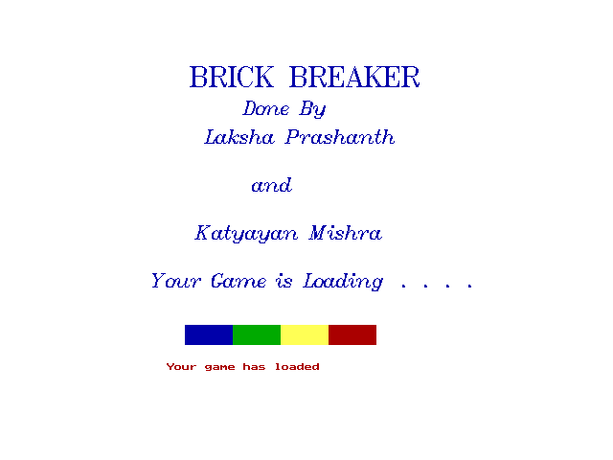

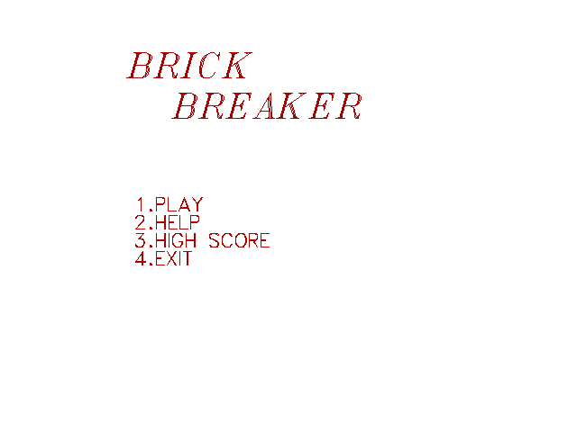

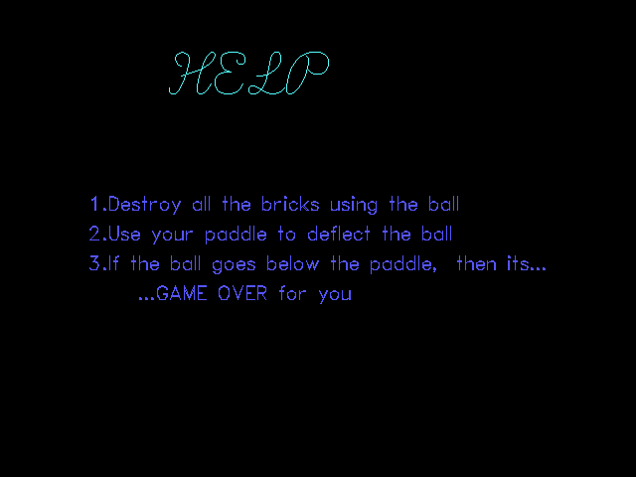

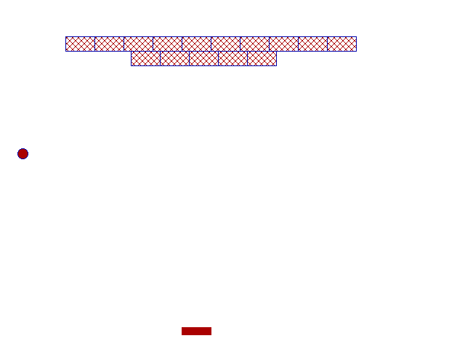

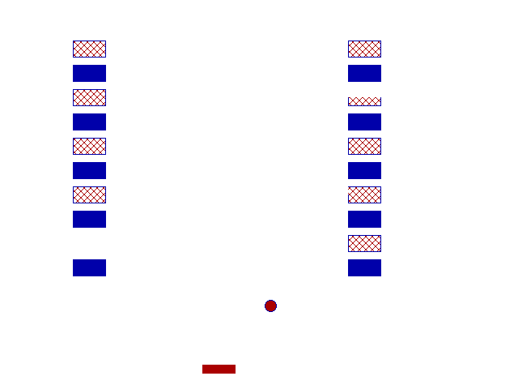

* Turbo C++
* 216 MB RAM
* 8.97 GB Hard Disk Space
* VGA Display Card
* MS-DOS(Windows 98,2000,XP)
* Pentium 2 or Higher(1 Ghz)
* Sumita Arora Text Book